**DATABASE MANAGEMENT SYSTEM**

**LAB 4**

**DML COMMANDS**

NAME: VISHWAS M

SRN: PES2UG20CS390

SEC: F

DATE : 10/09/2022

TASK 1 QUERIES:

1. 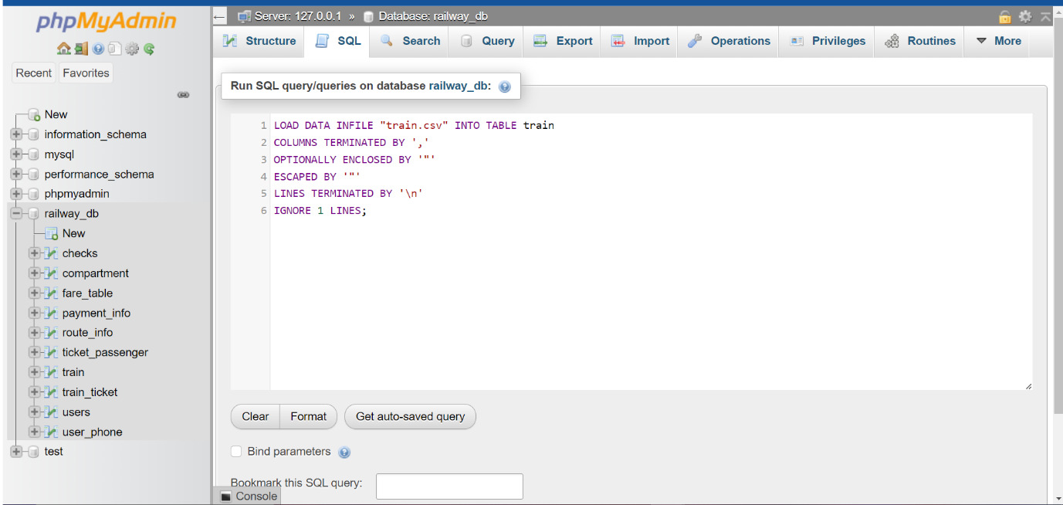
2. 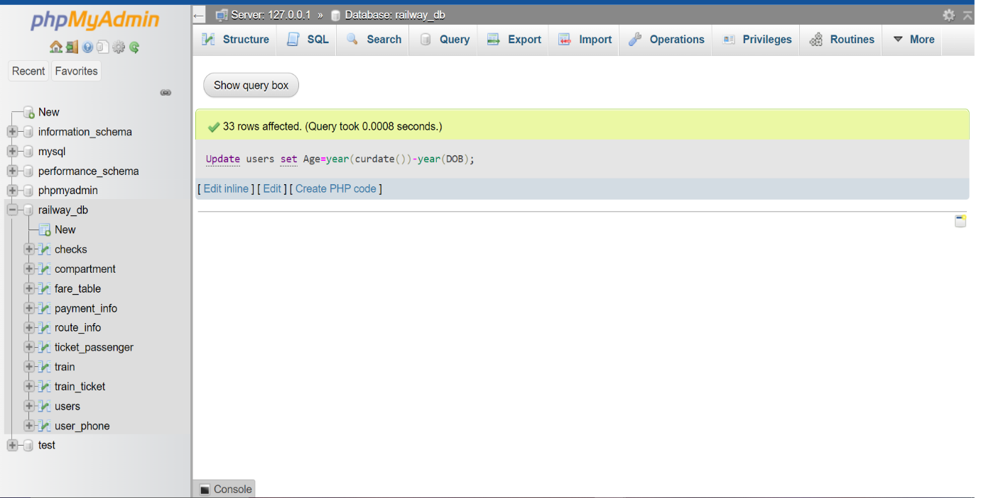

1. 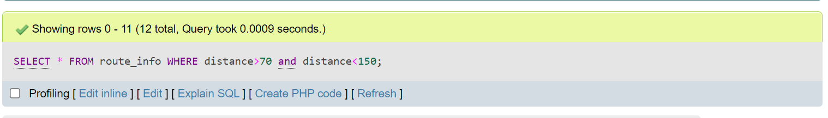
2. 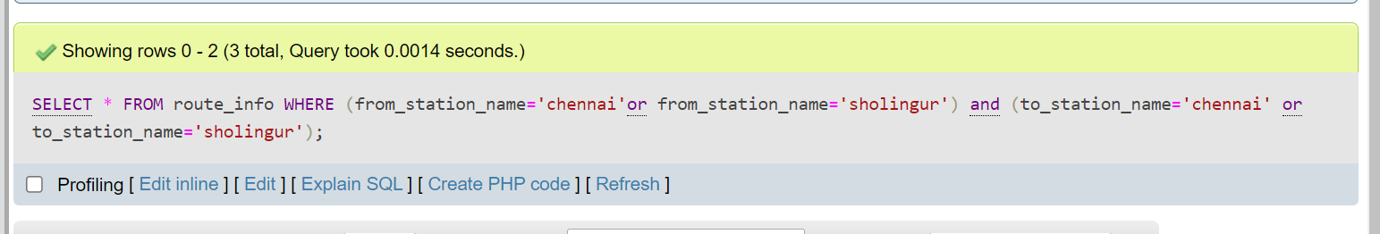
3. 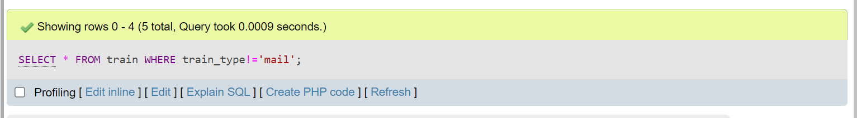
4. 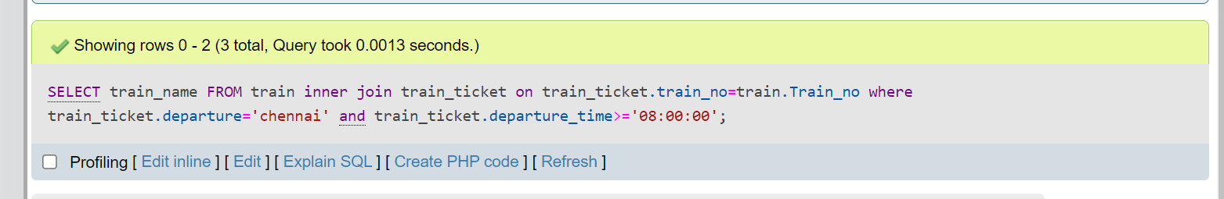
5. 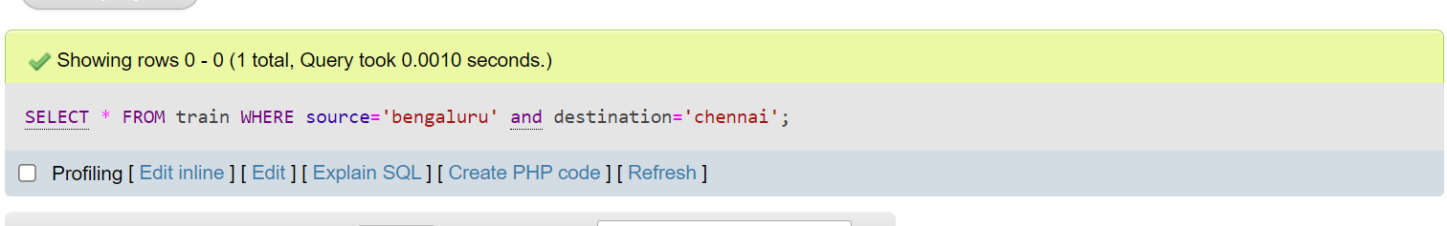
6. 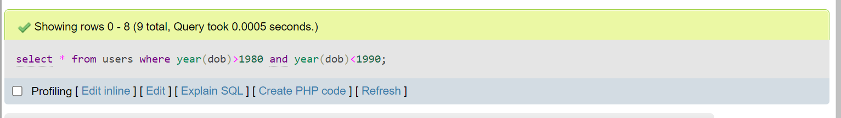
7. 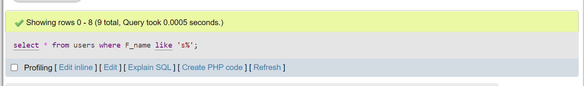
8. 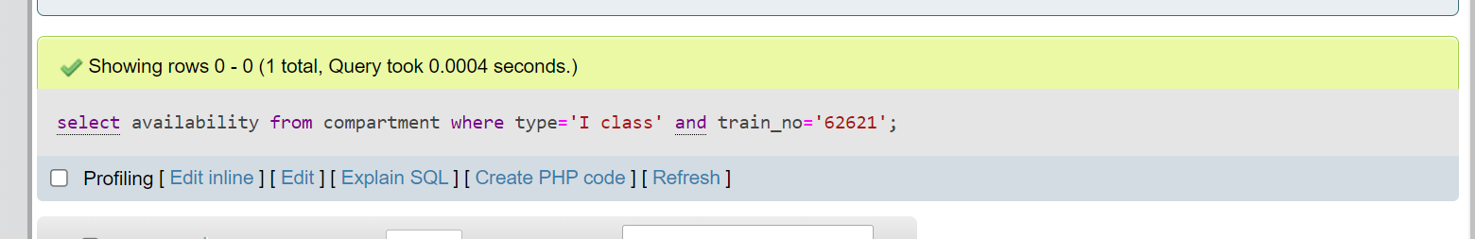
9. 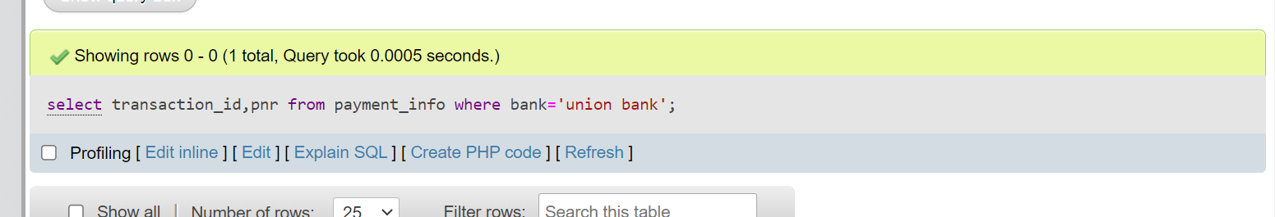

TASK 2 QUERIES:

1)

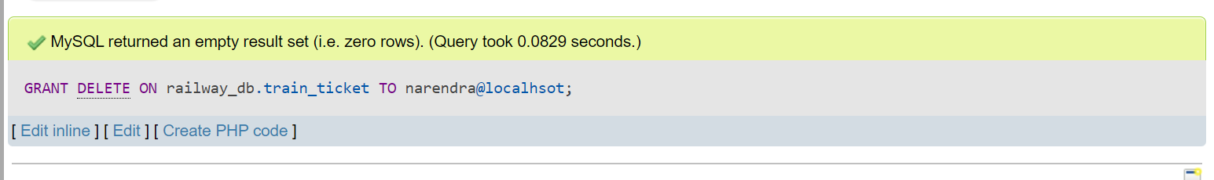 i)

ii)

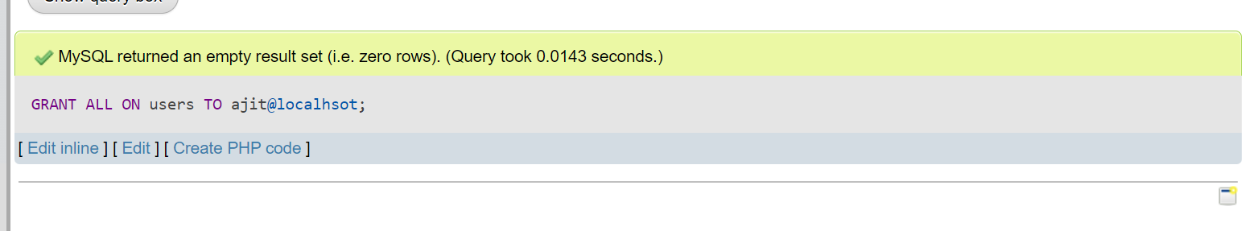

2) 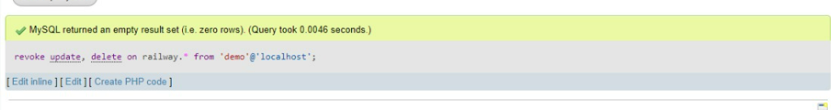

3)Creating savepoints:

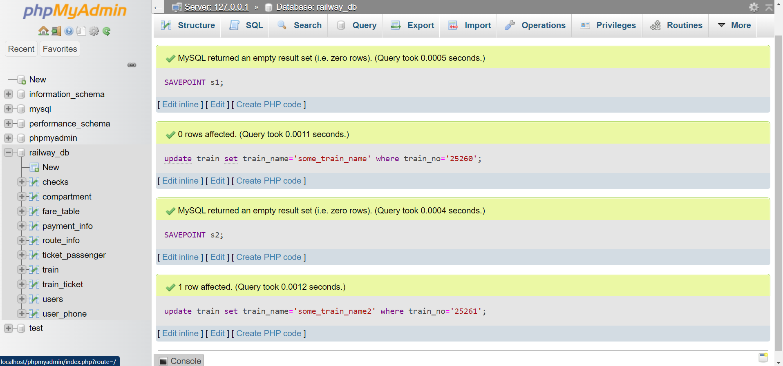

Rollback to savepoint s1:

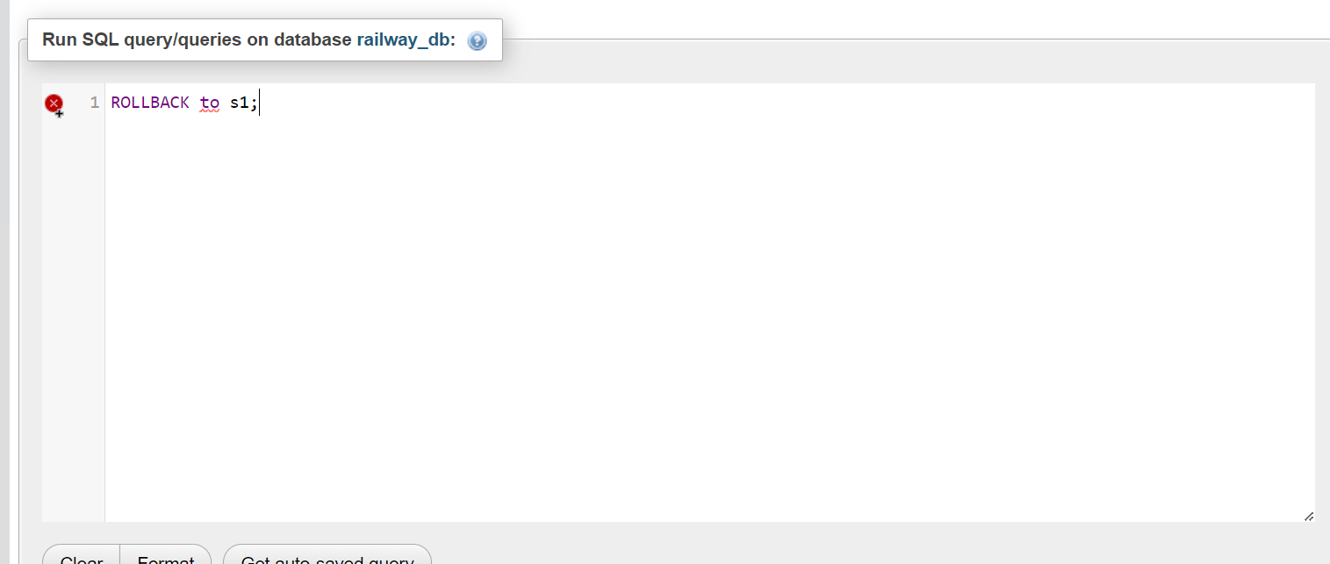

Using commit:

